February 19, 2022

*Sent Via E-mail:* <<OPPOSING_COUNSEL_EMAIL>>

<<OPPOSING_COUNSEL_NAME>>

***RE:*** *<<PROVIDER_SUITNAME>> a/a/o <<INJUREDPARTY_NAME>> v. <<INSURANCECOMPANY_SUITNAME>>, Case No.* <<INDEXORAAA_NUMBER>>

***Settlement Communication: The following confidential communication is intended only for settlement purposes and as an offer of compromise only, and may not be used for any other purpose than as intended.  The following communication is privileged within the meaning and intent of Florida Statute §90.408 and other applicable law and may not be deemed as an admission against interest whether pursuant to Florida Statute §90.803(18) or otherwise.***

Dear Counselor,

Please advise as to your availability to meet and confer to discuss possible resolution of this matter or narrowing the issues of the litigation and procedural matters.

I am available at your convenience so please let me know a good date and time. Alternatively I can have my assistant reach out to yours to coordinate a call. Please let me know what you prefer.

Sincerely,

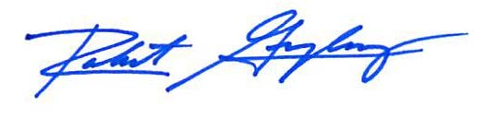

Robert F. Gonzalez, Esq.